
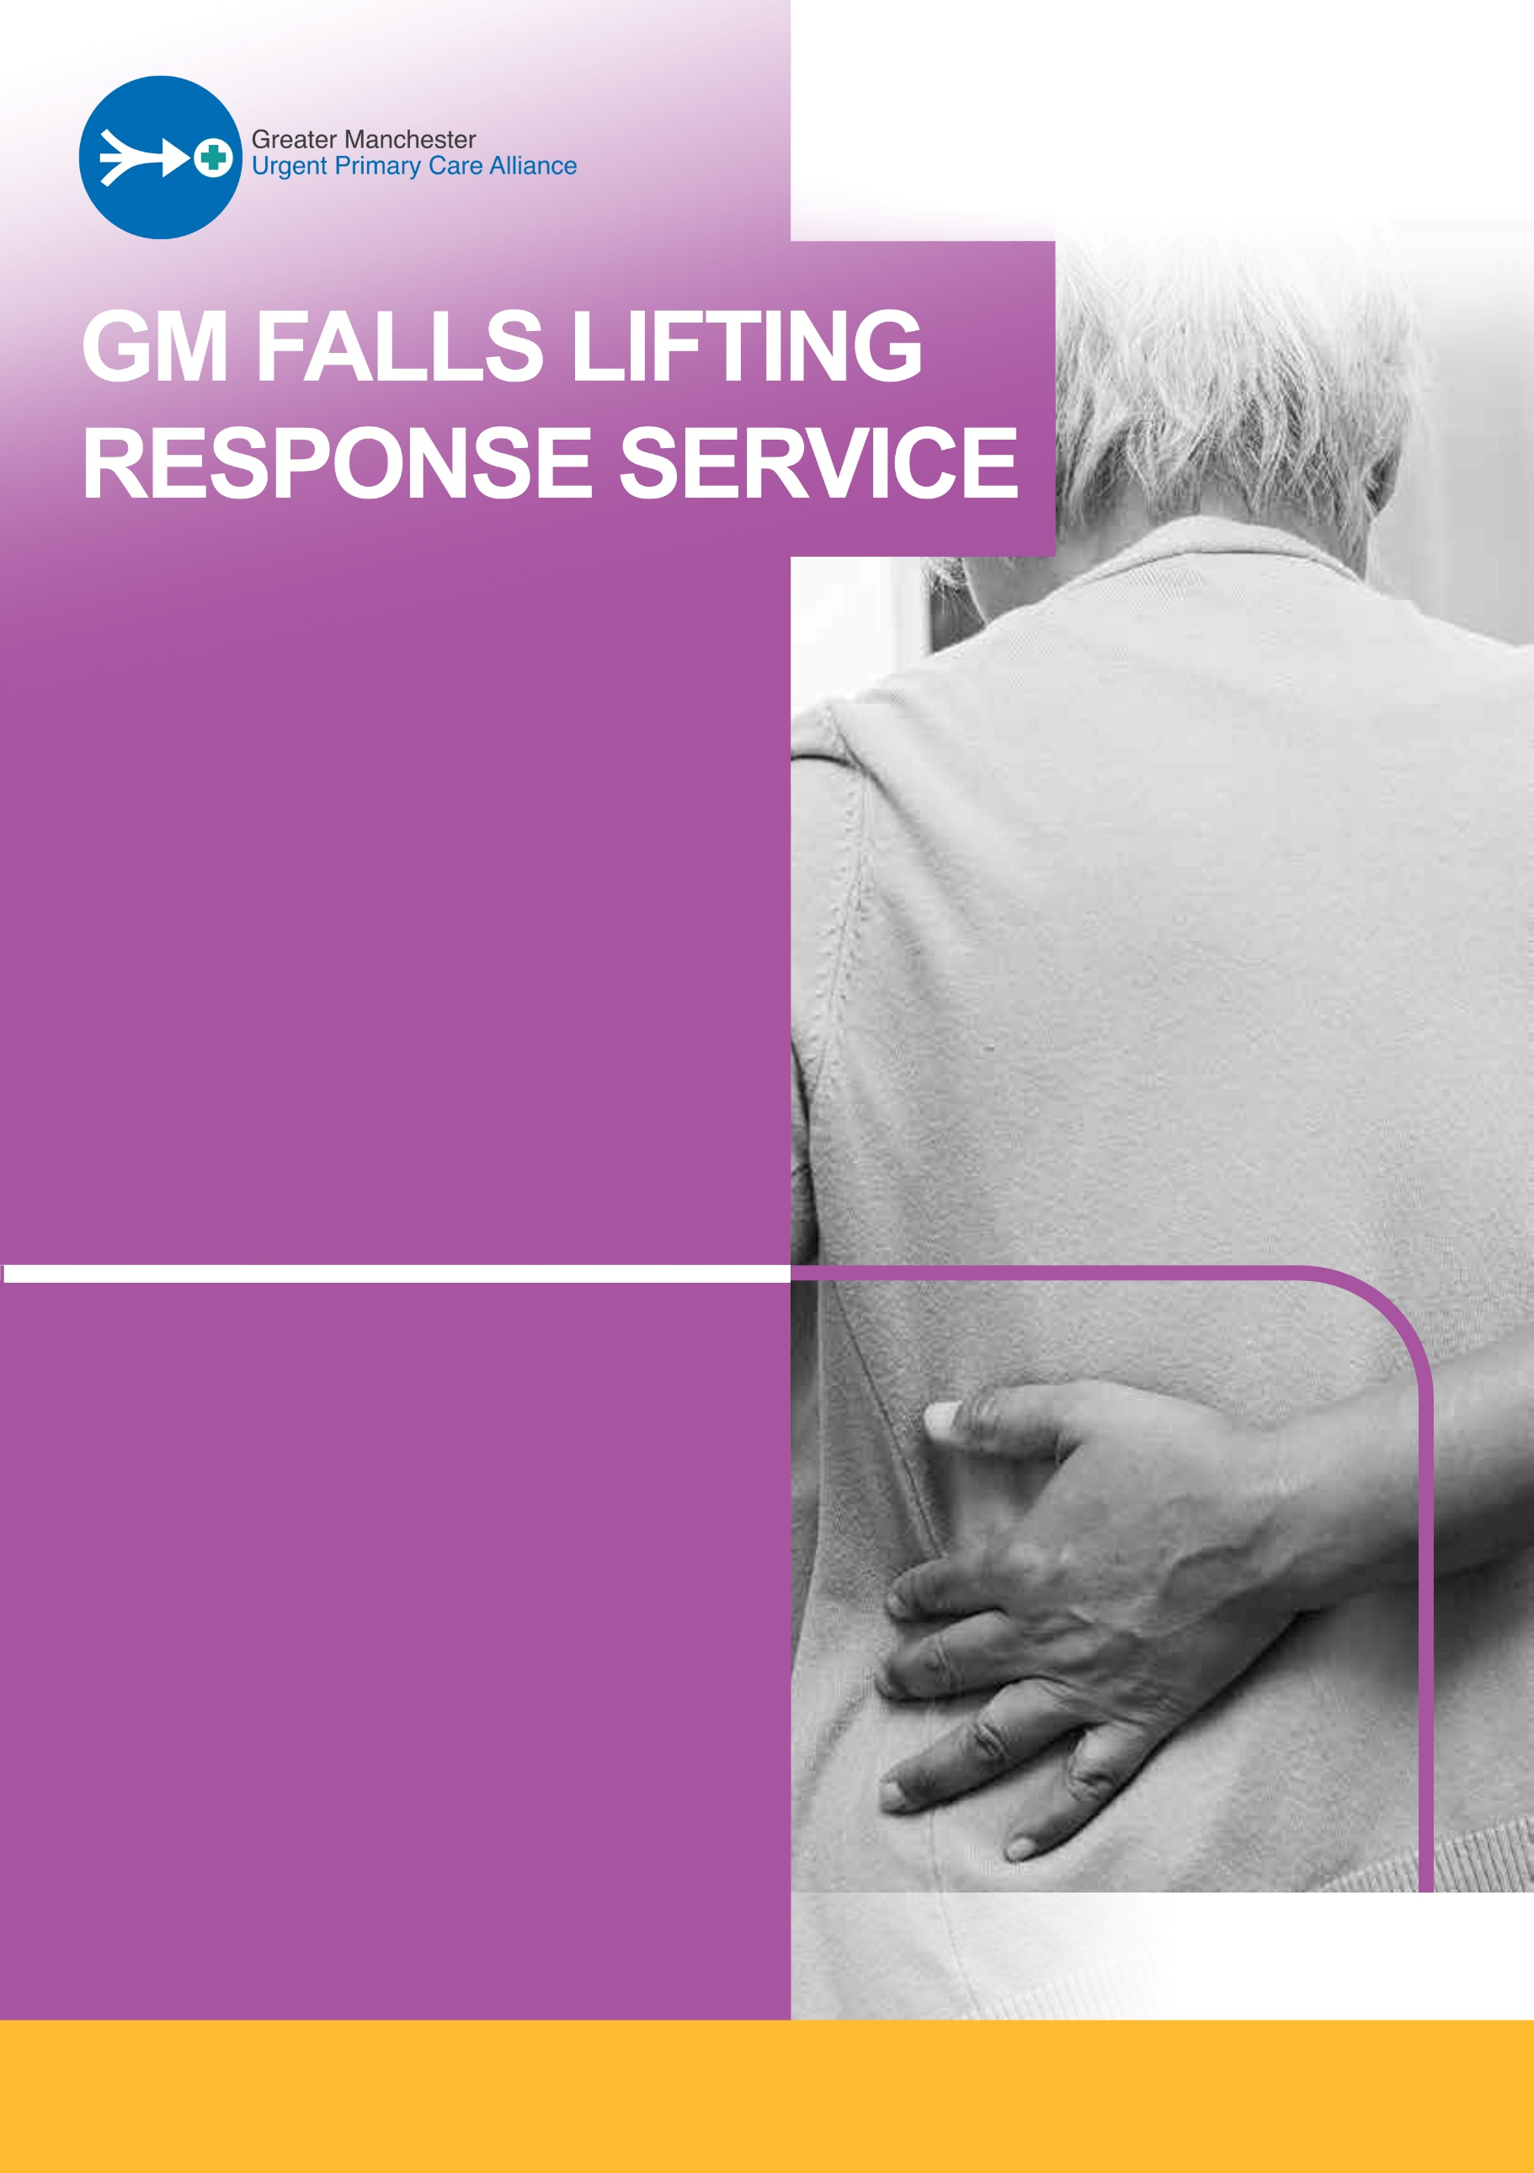
MUST CALL 999
The service operates from 8am to 8pm 7 days a week, including bank holidays.
Please note the last referral will be 7pm.
If the patient is injured or in a life-threatening emergency situation you
If a patient has fallen, is not injured and you need assistance, the winter GM Falls Lifting Response Service is a FREE service with a one hour response time.
WINTER SERVICE
For assistance please call:
0161 476 9652
The service will operate from 1 October 2026 to 31 March 2027
For immediate support

