

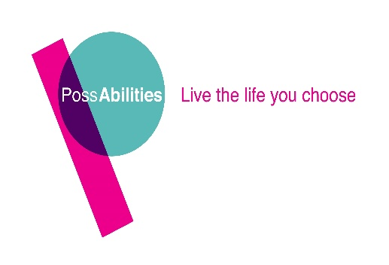

This role is part-funded by the European Social Fund as part of the 2014-2020 European Structural and Investment Funds Growth Programme in England.
POSSABILITIES CIC
JOB DESCRIPTION

Employment Officer
Mental Health
IPS

This is an important job with PossAbilities CIC. That’s because we regard every one of our jobs as important. We want people who are passionate, caring and fun. If this sounds a bit like you then carry on reading. You’ll find all you need to know in this job description. If there’s something you are not clear about, please contact us.

Where?
Bolton with one day a week at our Rochdale Office

What?
To deliver Individual Placement and Support (IPS programme) for Greater Manchester Working Well Specialist Employment Service.

Rewards
The salary for Employment Officer is £23.388 per annum based on 37 hours. We will pay up to an additional 4% of your salary into a pension plan for you, which will grow every year until you retire.

You will have a chance to progress. We give you training and help you gain relevant qualifications.

That’s not all. You’ll get twenty days paid holiday plus eight statutory bank holidays.

Who do you report to?

On a day-to-day basis, you will be working under the direction of the Employment Team Leader.

The hours

The needs of the programme participant come first, and so we need flexibility when it comes to your working hours. We generally work anytime between the hours of 8.00am and 5.00pm. However, there may be occasions when evening or weekend working will be necessary in order to support a customer in work.

The essential purpose of this job

IPS (Individual Placement and Support) supports people with severe mental health difficulties into employment. It involves intensive, individual support, a rapid job search followed by placement in paid employment, and in-work support for both the employee and the employer. This role is part based between the Bolton Mental Health Teams, our Rochdale Office with some remote working

Work with Participants

- The role of this post is to support people with Mental Health needs participating in the GM Working Well Specialist Employment Service. The aim is to support participants to secure and sustain appropriate employment opportunities following the Individual Placement and Support model and competence framework, following IPS Fidelity Principles.

- This is a target driven role in which you will be responsible for and expected to achieve results and targets by securing paid employment outcomes for your caseload of participants.

- You will provide advice and guidance to ensure that your caseload works towards achieving paid employment outcomes.

- You will assess the support needs and aspirations of participants through the use of profiling enabling you to match them to job opportunities.

- It would be your general duty to support participants in building their confidence and self-esteem. Assisting them with job search, helping them to apply for jobs and support in getting them prepared for interviews.

- Host and complete reviews to ensure that goals are being worked towards and targets met.

- To be proficient in IT and keep accurate records through the use of an electronic reporting system and relevant written documentation.

Employers
- You will be responsible for sourcing and securing suitable job opportunities for the participants on your caseload. The emphasis with IPS focusing on rapid job search.

- You will also be responsible for negotiating with employers on the Participants behalf.

- You will negotiate reasonable adjustments in the workplace and support employers to create suitable job opportunities through job carving.

- You must consider the health and safety of your participants and complete an assessment of work place risks in relation to each participants needs.

- It is important that you are able to build strong and professional working relationships with employers.

- You must carry out reviews with the employer and participant together, to ensure that competencies are being met and any training required can be put into place.

- It will be necessary to offer one-one support until they have learned the job requirements and have settled into the workplace.

- On-going support, both in and out of work is also given, to ensure the individual sustains their employment

- To monitor and review service users in the workplace.

Your general duties

- Ensure all financial transactions comply with PossAbilities procedures.

- To ensure the proper use of material/equipment resources.

- To take appropriate action to maintain equipment and bring to the attention of the appropriate person any defect or problems with the equipment.

- Responsibility for the safety and welfare of self, colleagues, customers and members of the public in accordance with the Health and Safety Policies of PossAbilities.

- To work in accordance with PossAbilities Policies relating to the promotion of Equality and Diversity.

- The post holder will be responsible for assisting in the identification and undertaking of his/her own training and development requirements.

- Ensure that PossAbilities statutory requirements and policies are carried out efficiently, effectively, economically and equitably.

- Perform his/her duties in accordance with PossAbilities Equality and Diversity

- To keep accurate records as required.

Secondary Duties

- To participate in PossAbilities programmes of in- service training.

- To attend regular staff meetings and, other relevant meetings as and when required.

- To maintain a working knowledge of routine fire safety and health and safety procedures.

- To provide appropriate cover for other colleagues across the service during holidays, sickness or training.

- To carry out administrative tasks as appropriate to the needs of the service.

- To participate in planned supervision and personal development reviews.

- To undertake such other duties and responsibilities of an equivalent nature as may be determined from time to time by the CEO (or nominated representative) in consultation with the post holder (and if he/she so wishes, with his/her Trade Union representative).

Our values lie at the heart of the organisation and underpin everything we do. It is essential that all staff share our values and work together in achieving our mission statement

Values and Behaviours

Approach the job at all times using the values set out by PossAbilities CIC.

- Integrity – we communicate openly and honestly and build relationships based on trust, respect and caring.

- Creativity – we thrive on innovation and encourage positive risk taking.

- Happy – we believe fun is the key to success.

- Person centred – we believe that everyone has the right to exercise choice and control in directing their lives and support. We inspire people to achieve greater things.

- Passionate – we are dedicated and enthusiastic to providing exceptional services.
Signed: …………………………………………..

Date: …30/01/2022…………………………………………….

