

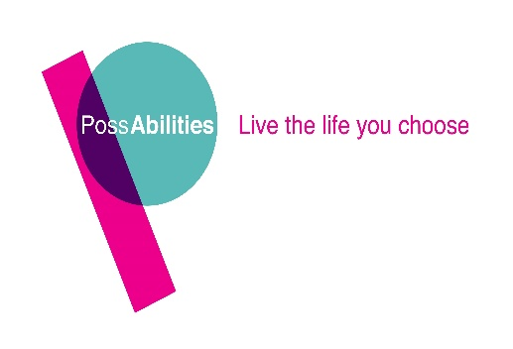

This role is part-funded by the European Social Fund as part of the 2014-2020 European Structural and Investment Funds Growth Programme in England.

Person Specification

Job role: IPS Employment Officer Mental Health

Section: Day Services

Interviews: Week Commencing 20th February

As part of our recruitment process we require that inform us about your skills, knowledge and experiences you have had to date, these can either be paid or voluntary.

Please provide written details in relation to each criteria listed below. If you show that you have the skills and knowledge we are looking for, you will be invited to interview and asked further questions.

Possabilities wish you the very best of luck in applying for the position.

Essential to the Job Role.

Please complete the application form telling us about your qualifications, skills and experiences: Please note these are essential in order to be interviewed.

Please tell us about your experience and qualifications:
- NVQ Level 3, A levels or equivalent/Higher qualification
- Experience of working with people with Mental Health needs and an understanding of the barriers they may face when accessing employment.
- Experience of supporting people with mental health needs in a community, learning or employment environment.
- Experience of working to a target driven project.

Please tell us what skills and knowledge you have:

- Ability to negotiate with and support employers to find sustainable paid employment opportunities.
- Ability to offer support in the Workplace.
- Ability to self-motivate, plan and prioritise your own workload.
- Ability to work as part of a team.
- Excellent verbal, written and interpersonal communication skills
- Ability to complete administration tasks to a high standard, meeting any timescales or deadlines.
- Confident use of I.T equipment.
- An understanding of the Health & Safety at Work Act, taking care of your own health and safety and that of colleagues, clients and the public.
- An understanding of Safeguarding Practices and a commitment to ensuring the safety and well-being of the programme participants.
- Awareness of and a commitment to equality and diversity.

Please tell us about your ability or willingness to adhere to our SPECIAL WORKING CONDIDITONS:
- Flexibility in terms of working hours, as some evening and weekend work may be required.
- Commitment to further training and development.
- To be able to drive and have use of a car

Please tell us about anything which is relevant to our DESIRABLE CRITERIA:

- Experience of working in a multi-disciplinary setting.
- Previous experience in working in the Supported Employment sector.
- Sales and Marketing experience or training.

We need people who will approach the job, at all times, using the values set out by PossAbilities:

• Integrity – we communicate openly and honestly and build relationships based on trust, respect and caring.

• Creativity – we thrive on innovation and encourage positive risk taking.

• Happy – we believe fun is the key to success.

• Person Centred – we believe that everyone has the right to exercise choice and control in directing their lives and support. We inspire people to achieve greater things.

• Passionate – we are dedicated and enthusiastic in providing an exceptional service.

How do our values apply to you? Tell us why you think you are the right person for the job.

